FULL STACK APPLICATION DEVELOPMENT
SKILL – 3: Working with HQL - Sorting, Pagination & Aggregates

Name | Maramreddy Praveen Reddy
ID | 2400032662
Section | S-3
Subject | FULL STACK APPLICATION DEVELOPMENT

Aim
To perform advanced data retrieval operations using Hibernate Query Language (HQL) such as sorting, pagination, filtering, grouping, and aggregate functions.

Prerequisites
- Basic knowledge of Hibernate
- Basic idea of HQL syntax

Software Requirements
- Java 8
- MySQL
- Eclipse IDE
- Hibernate 5.6
- Maven

Task 1: Insert 5–8 Product Records
HQL / Hibernate Code:

session.save(product);

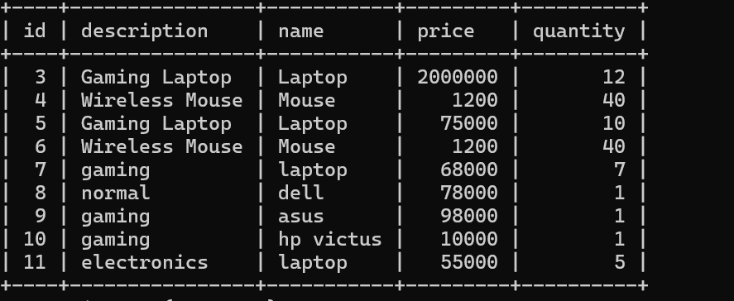
Output Screenshot:

Task 2: Sort Products by Price (Ascending)

from Product order by price asc

Output Screenshot:

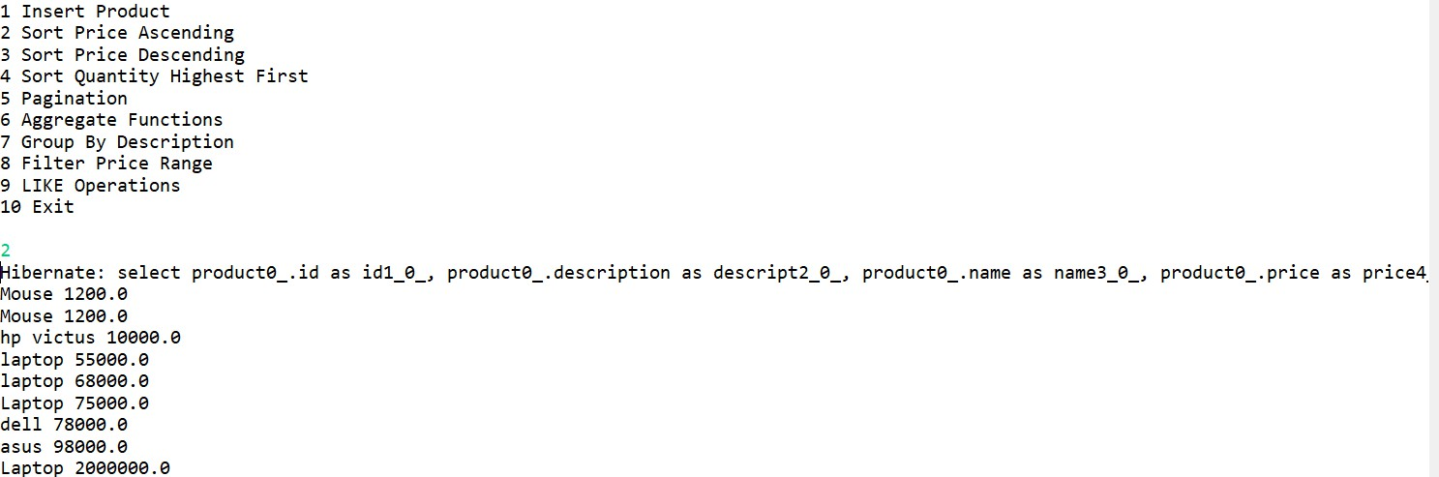

Task 3: Sort Products by Price (Descending)

from Product order by price desc

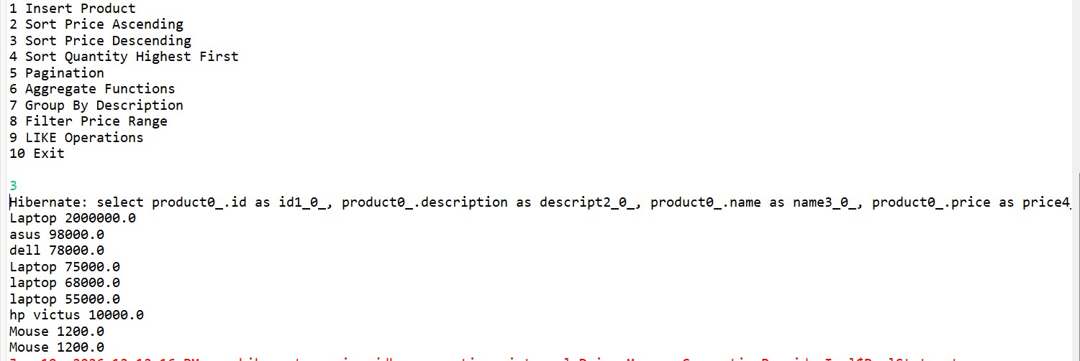
Output Screenshot:

Task 4: Sort by Quantity (Highest First)

from Product order by quantity desc

Output Screenshot:

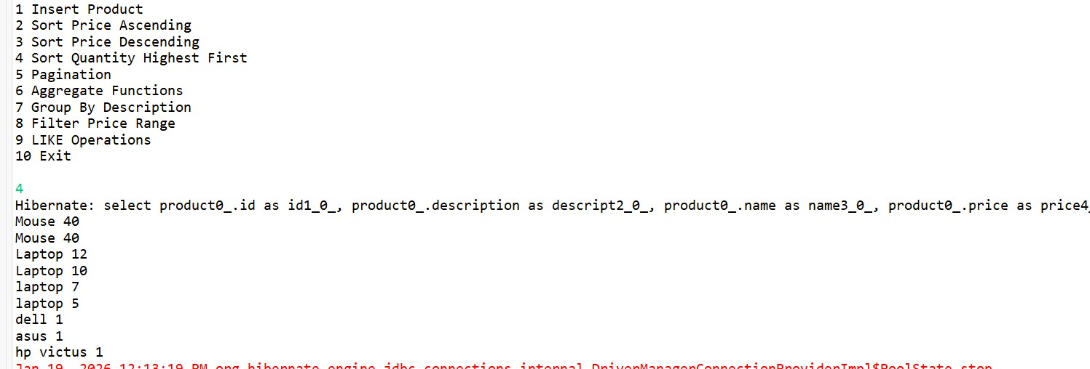

Task 5: Pagination

Query q = session.createQuery("from Product"); q.setFirstResult(0);
q.setMaxResults(3);

Output Screenshot:
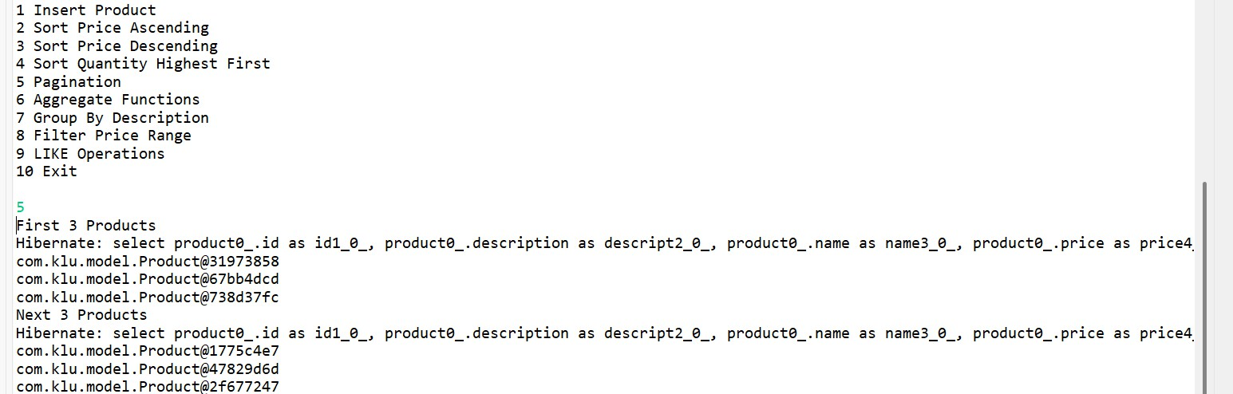

Task 6: Aggregate Functions

select count(*) from Product select min(price) from Product select max(price) from Product

Output Screenshot:

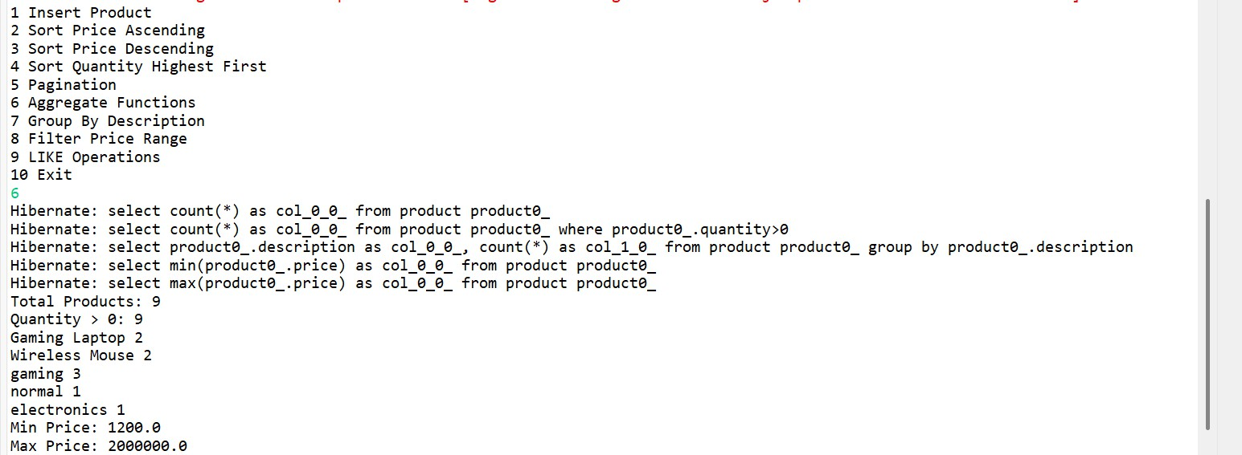

Task 7: Group By Description

select description, count(*) from Product group by description

Output Screenshot:
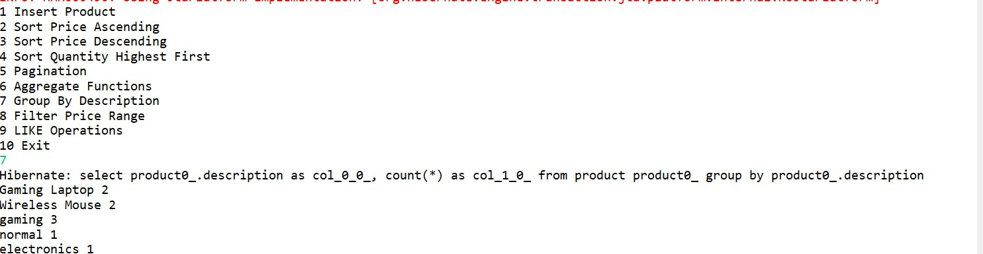

Task 8: Filter Products Using WHERE

from Product where price between :min and :max

Output Screenshot:
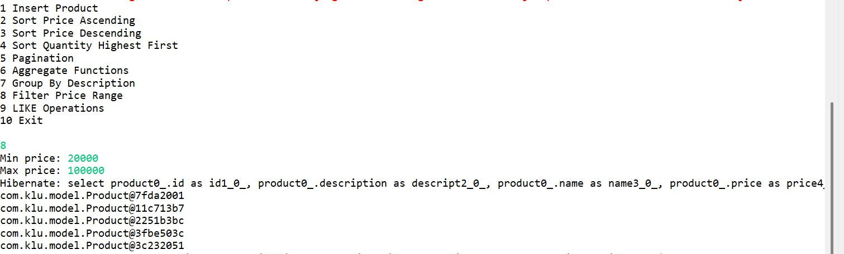

Task 9: LIKE Operations

name like 'A%' name like '%p' name like '%ou%' length(name)=5

Output Screenshot:
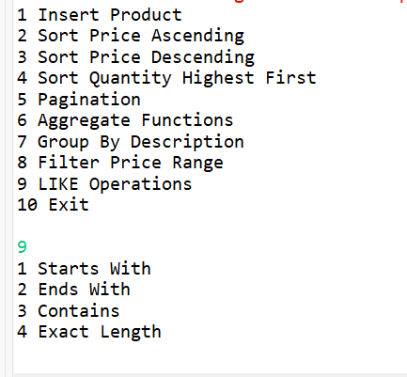

Task 10: GitHub Repository
Project successfully pushed to GitHub.
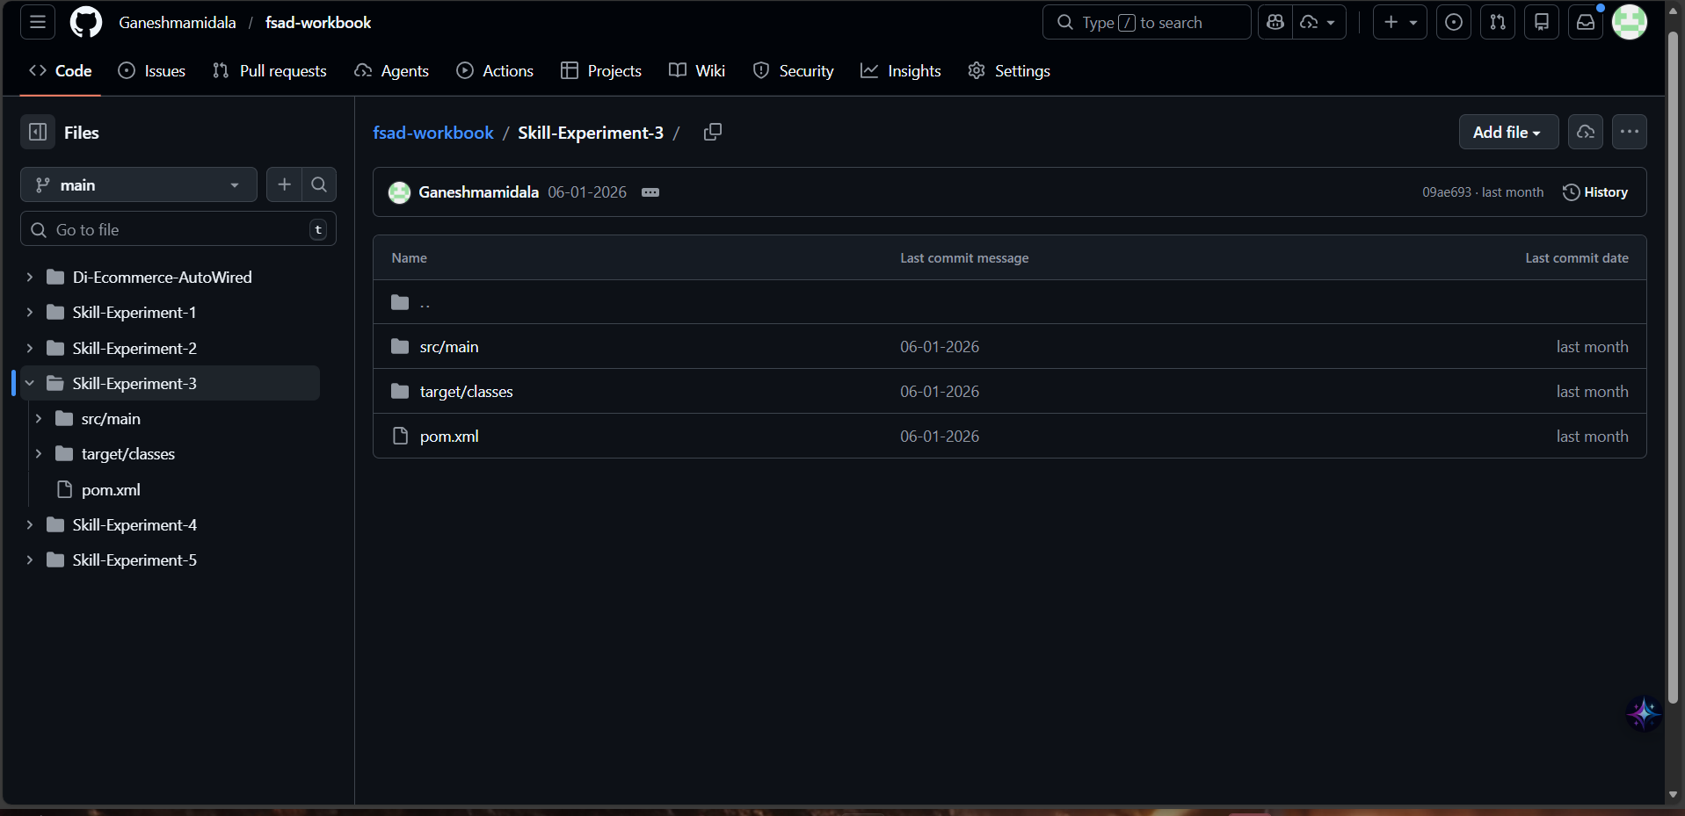

Result
All HQL operations including sorting, pagination, filtering, grouping and aggregate functions were successfully implemented using Hibernate.
Codes:

MainApp:
package com.klu.mainapp;

import com.klu.model.Product;

import org.hibernate.*;
import org.hibernate.cfg.Configuration;

import java.util.List;
import java.util.Scanner;

public class MainApp {

public static void main(String[] args) {

Scanner sc = new Scanner(System.in);

SessionFactory sf = new Configuration().configure().buildSessionFactory(); Session session = sf.openSession();
Transaction tx = session.beginTransaction();

System.out.println("1 Insert Product"); System.out.println("2 Sort Price Ascending"); System.out.println("3 Sort Price Descending"); System.out.println("4 Sort Quantity Highest First"); System.out.println("5 Pagination"); System.out.println("6 Aggregate Functions"); System.out.println("7 Group By Description"); System.out.println("8 Filter Price Range"); System.out.println("9 LIKE Operations"); System.out.println("10 Exit");

int ch = sc.nextInt();

switch (ch) {

case 1:
System.out.print("How many products: ");
int n = sc.nextInt();

for (int i = 0; i < n; i++) { Product p = new Product();

System.out.print("Name: ");
p.setName(sc.next());

System.out.print("Description: "); p.setDescription(sc.next());

System.out.print("Price: "); p.setPrice(sc.nextDouble());

System.out.print("Quantity: "); p.setQuantity(sc.nextInt());

session.save(p);
}
tx.commit(); System.out.println("Products inserted"); break;

case 2:
List<Product> asc =
session.createQuery("from Product order by price asc", Product.class).list(); asc.forEach(p ->
System.out.println(p.getName() + " " + p.getPrice()));

break;

case 3:
List<Product> desc =
session.createQuery("from Product order by price desc", Product.class).list(); desc.forEach(p ->
System.out.println(p.getName() + " " + p.getPrice()));

break;

case 4:
List<Product> qty =
session.createQuery("from Product order by quantity desc", Product.class).list();
qty.forEach(p ->
System.out.println(p.getName() + " " + p.getQuantity()));

break;

case 5:
Query q = session.createQuery("from Product"); q.setFirstResult(0);
q.setMaxResults(3); System.out.println("First 3 Products"); q.list().forEach(System.out::println);

q.setFirstResult(3); q.setMaxResults(3); System.out.println("Next 3 Products"); q.list().forEach(System.out::println); break;

case 6:
Long total =
(Long) session.createQuery("select count(*) from Product").uniqueResult();

Long available =
(Long) session.createQuery("select count(*) from Product where quantity>0").uniqueResult();

List<Object[]> group =
session.createQuery("select description,count(*) from Product group by description").list();

Double min =
(Double) session.createQuery("select min(price) from Product").uniqueResult();

Double max =
(Double) session.createQuery("select max(price) from Product").uniqueResult();

System.out.println("Total Products: " + total); System.out.println("Quantity > 0: " + available); group.forEach(o ->
System.out.println(o[0] + " " + o[1]));

System.out.println("Min Price: " + min); System.out.println("Max Price: " + max); break;

case 7:
List<Object[]> grp =
session.createQuery("select description,count(*) from Product group by description").list();
grp.forEach(o ->
System.out.println(o[0] + " " + o[1]));

break;

case 8:
System.out.print("Min price: "); double minp = sc.nextDouble(); System.out.print("Max price: "); double maxp = sc.nextDouble();

Query range =
session.createQuery("from Product where price between :a and :b"); range.setParameter("a", minp);
range.setParameter("b", maxp);

range.list().forEach(System.out::println);

break;

case 9:
System.out.println("1 Starts With"); System.out.println("2 Ends With");

System.out.println("3 Contains"); System.out.println("4 Exact Length");

int like = sc.nextInt();

if (like == 1) { System.out.print("Enter letters: "); String s = sc.next() + "%";
session.createQuery("from Product where name like :x")
.setParameter("x", s)
.list().forEach(System.out::println);
}

if (like == 2) { System.out.print("Enter letters: "); String s = "%" + sc.next();
session.createQuery("from Product where name like :x")
.setParameter("x", s)
.list().forEach(System.out::println);
}

if (like == 3) { System.out.print("Enter letters: "); String s = "%" + sc.next() + "%";
session.createQuery("from Product where name like :x")
.setParameter("x", s)
.list().forEach(System.out::println);
}

if (like == 4) { System.out.print("Enter length: "); int len = sc.nextInt();
session.createQuery("from Product where length(name)=:l")
.setParameter("l", len)
.list().forEach(System.out::println);
}

break;

case 10:
System.out.println("Program Ended");

break;
}

session.close(); sf.close();
}
}

Product.java:
package com.klu.model;

import javax.persistence.*;

@Entity
@Table(name = "product")

public class Product {

@Id
@GeneratedValue(strategy = GenerationType.IDENTITY)

private int id;

private String name; private String description; private double price; private int quantity;

public int getId() {
return id;
}

public String getName() {
return name;
}

public String getDescription() {
return description;
}

public double getPrice() {
return price;
}

public int getQuantity() {

return quantity;
}

public void setName(String name) {
this.name = name;
}

public void setDescription(String description) {
this.description = description;
}

public void setPrice(double price) {
this.price = price;
}

public void setQuantity(int quantity) {
this.quantity = quantity;
}
}

Hibernate.cfg.xml:

package com.klu.model;

import javax.persistence.*;

@Entity
@Table(name = "product")

public class Product {

@Id
@GeneratedValue(strategy = GenerationType.IDENTITY)

private int id;

private String name; private String description; private double price; private int quantity;

public int getId() {
return id;
}

public String getName() {
return name;
}

public String getDescription() {
return description;
}

public double getPrice() {
return price;
}

public int getQuantity() {

return quantity;
}

public void setName(String name) {
this.name = name;
}

public void setDescription(String description) {
this.description = description;
}

public void setPrice(double price) {
this.price = price;
}

public void setQuantity(int quantity) {
this.quantity = quantity;
}
}

Pom.xml:

<project xmlns="http://maven.apache.org/POM/4.0.0" xmlns:xsi="http://www.w3.org/2001/XMLSchema-instance" xsi:schemaLocation="http://maven.apache.org/POM/4.0.0 http://maven.apache.org/xsd/maven-4.0.0.xsd">

<modelVersion>4.0.0</modelVersion>

<groupId>com.klu</groupId>
<artifactId>HibernateSkill3</artifactId>
<version>1.0</version>

<properties>
<maven.compiler.source>1.8</maven.compiler.source>
<maven.compiler.target>1.8</maven.compiler.target>
</properties>

<dependencies>

<dependency>
<groupId>org.hibernate</groupId>
<artifactId>hibernate-core</artifactId>
<version>5.6.15.Final</version>
</dependency>

<dependency>
<groupId>javax.persistence</groupId>
<artifactId>javax.persistence-api</artifactId>
<version>2.2</version>
</dependency>

<dependency>
<groupId>mysql</groupId>
<artifactId>mysql-connector-java</artifactId>

<version>8.0.33</version>
</dependency>

<dependency>
<groupId>org.slf4j</groupId>
<artifactId>slf4j-simple</artifactId>
<version>1.7.36</version>
</dependency>

</dependencies>

</project>

